Create a project in VOTT part 3

**Step 3:**

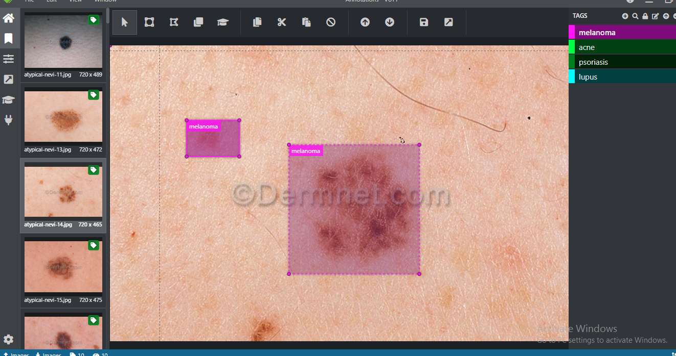

**Step 4:**

